GoN Regd. No. 82/064-065, Social Welfare Council (SWC) Aff. No 23160, PAN No. 303408956

Logo Nepali
Logo English

Centre for Environment and Sustainable Tourism Development Nepal (CEST Nepal)

ABOUT CEST NEPAL
Background
Vision
Mission
Goal
Objectives

ORGANIZATION STRUCTURE
Governing body
Professional staff
Working approach

MAJOR PROGRAMME AREAS
Thematic areas
Major activities
Completed activities
Ongoing activities
Working partners
ONGOING/UPCOMING EVENTS/PROGRAMME
PHOTO GALLERY

CONTACT

ABOUT CEST NEPAL

Background
CEST Nepal is a non Governmental and non-profit making organization committed to contribute to the sustainable tourism development and environmental management in Nepal. By getting registration at the District Administration Office Kathmandu, affiliated at the Social Welfare Council (SWC) Nepal and by getting the Permanent Account Number (PAN) from the Department of Internal Revenue, CEST Nepal has become a legally existed entity working in tourism and environment in Nepal. Established in August 2007 by some young and energetic professionals; CEST Nepal has build a positive image in Nepal for its contribution to the tourism development in Nepal.

Vision
CEST Nepal envisions a beautiful, well preserved, well cultured and prosperous new Nepal where responsible tourism could have prevailed and a maximum population of the country could have been benefited from tourism on a sustainable and equitable manner.

Mission
CEST Nepal dreams to be established as a champion, intellectually sound and leading NGO in tourism and environment sector in Nepal to contribute the nation through the responsible tourism development, heritage preservation and environment management.

Goal
The goal of CEST Nepal is to contribute to the development of sustainable tourism in Nepal while preserving its rich natural and cultural heritage and enhancing the livelihoods of the people.

Objectives of CEST Nepal

As elaborated in the approved constitution of the CEST Nepal, the primary objectives of CEST Nepal are to:
- Support to carryout awareness programme on culture, tourism and environment management,
- Support to develop pro-environment, pro-community and pro-cultural responsible tourism in Nepal,
- Support to improve the livelihood of rural community by identifying, developing and managing tourism through social mobilization process,
- Carry out action research and surveys to generate and disseminate information on tourism and environment to the concerned stakeholders
- Support to conserve the floral and faunal biodiversity; preserving the landscape and the watershed by undertaking the activities on environmental conservation and management,
- Contribute to the preventive and corrective measures for combating the climate change effects by undertaking awareness programme and research activities on the interrelationship between tourism, livelihoods and climate change,
- Support local community to manage and improve information and interpretation facilities at the tourist destination
- Support to improve the skills and capacity of rural community for tourism development and environment management,
- Support to implement partnership programme on tourism and environment at local, regional and national level,
- Carry out lobbing and advocacy activities for policy changes for people-centered tourism and environment management in Nepal

ORGANIZATION STRUCTURE

CEST Nepal governing body
CEST Nepal is governed by the Executive Committee comprising 9 members from the diversified field of Tourism, Environment, Sociology, Geography, Agriculture, Economics, Population, Law etc. The Executive Committee is also backed by the several sub committees including Tourism and culture sub-committee, Social and gender inclusion sub-committee, Environment and climate change sub-committee etc as and when required.

A Glimpse of CEST Nepal Executive Committee members

Name | Position | Expertise
Mr. Ram Chandra Sedai | President | More than 20 years experiences in tourism, heritage preservation, biodiversity conservation, livelihoods
Mr. Kabi Prasad Bajgain | Vice President | Masters degree in Economic, Expertise in Rural economic, arts
Ms. Shova Acharya | Secretary | Hospitality/culinary
Mr. Raju Bhandari | Treasurer | Bachelors degree in Population and Hospitality Management (ongoing), Expertise in population studies, hospitality management
Ms, Ananta Pokharel | Member | Bachelors in Education
Ms. Laxmi Pun | Member | Masters in Tourism Studies, Bachelors in Travel and Tourism Management (BTTM)
Mr. Yubaraj Lama | Member
Mr. Binra Ram Yadav | Member | Basic Health Science
Dr. Bishwo Raj Subedi | Member | PhD (Tourism and Buffer Zone), Masters in Tourism Studies, MBA

CEST Nepal Professional staff
CEST Nepal is administered and functioned by a small team of young professionals. This team deals with the technical matters to ensure the effective implementation of the projects run by it.

A Glimpse of CEST Nepal Professionals

Name | Position | Education | Education and Background and expertise
Mr. Ram Chandra Sedai | President and Executive Director | Masters in Buddhism and Himalayan Studies (completed), Masters in Tourism Studies, Bachelors in Forestry, BBA | More than 20 years experiences in tourism, heritage preservation, biodiversity conservation, livelihoods
Mr. Yubaraj Lama | Programme Director | Masters in Anthropology
Mr. Subash Sharma Poudel | Field Coordinator |  | More than 10 years of experience in community development and livelihoods
Mr. Phurpu Singi Tamang | Field Coordinator |  | More than 15 years of experience in tourism, natural resource management and local development
 |  |  | More than 10 years of working experience in Culture, arts, tourism and community development
Ms. Kristina Sedai | Junior Officer | A Level (Math, Sociology and Psychology major) | 1 Year experience of internship with CEST Nepal

MAJOR PROGRAMME

Major Thematic areas of CEST Nepal
CEST Nepal has a mandate to focus its efforts in the following thematic areas
- Tourism development and management
- Culture and Heritage conservation
- Environment conservation and management
- Climate Change

Working approach of CEST Nepal
CEST Nepal adopts following as its working approach
- Social Mobilization as an entry point
- Partnership and collaboration at micro, meso and macro level
- Inclusive, gender-sensitive and focused on rural people
- Emphasis on developing the capacity of rural community and community based institutions

Major activities of CEST Nepal (Scope of CEST Nepal activities)
CEST Nepal aims to develop itself as a good facilitator and intellectually sound institution with knowledge, experiences and updated database in responsible tourism development, heritage conservation and environment management. CEST Nepal is undertaking various activities ranging from awareness campaign to the preparation of strategic plan for the tourism destination. In a nutshell, CEST Nepal mobilizes its resources in supporting and facilitating the following activities on tourism development and environment management:

- Awareness raising activities for tourism, culture and environment through campaign, exhibitions and other methods
- Conducting feasibility studies to explore new tourism products and destinations
- Carry out research and surveys for generating, documenting and disseminating information on tourism, culture and environment
- Conducting training and other capacity enhancement activities on tourism, culture and environment
- Mobilize resources for site/destination plan preparation and destination development planning
- Support implementing community based tourism development and heritage/environment conservation project

Major Programme completed by CEST Nepal
- Preliminary feasibility studies of new tourism destinations
  - Budhanilkantha-Gosaikunda trekking trail
  - Helambu-Panchpokhari trekking trail
- Preparation of tourism development and management plan of Manakamana, Betini and Bakreshwori areas of Gorkha for Nepal Tourism Board
- Facilitating Tourism and Hospitality Management Training for tourism entrepreneurs and chamber member in Palpa for Nepal Tourism Board.
- Exhibiting and disseminating tourism products through participating the exhibitions and fairs
- Assisting Dhorpatan Hunting Reserve to prepare Eco tourism component plan as a part of its Integrated Management Plan.

Programmes of CEST Nepal

- Community Awareness and Tourism promotion project (CATPP), Changunarayan

Major working partners and stakeholders
- Nepal Tourism Board
- Department of National Parks and Wildlife Conservation (DNPWC)
- District Chamber of Commerce and Industries (DCCIs)
- District Development Committees (DDCs)
- Village Development Committees (VDCs)
- Bhaktapur Tourism Development Committee (BTDC), Bhaktapur
- Changunarayan Tourism Development Committee (CTDC), Bhaktapur
- Trekking Agencies Association of Nepal (TAAN)
- Alliance for Responsible Tourism Nepal (ART Nepal)
- Trekking Agencies, Travel Agencies and other tourism related private sectors

CONTACT
For further exploration and information, please visit us at the following:
Centre for Environment and Sustainable Tourism Development Nepal (CEST Nepal)
P.O. Box No. 11758
New Baneshwor, Kathmandu, Nepal
Tel: 977-16219466,
Email: tourism@cestnepal.org.np, cestnepal@gmail.com
Website: www.cestnepal.org.np

PHOTO GALLERY

UPDATED INFORMATION

OTHER LINKs

Preliminary feasibility study of Budhanilkantha-Gosaikunda trekking trail

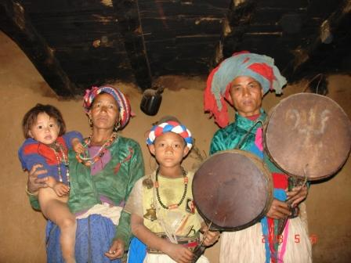
A preliminary feasibility study of Budhanilkantha-Samundratar-Gosaikunda route was carried out by CEST Nepal in December 2007. A team of explorer comprising Mr. Ram Chandra Sedai of CEST Nepal, Journalist Mr. Krishna Thapa, and locals Mr. Krishna Bahadur Tamang and … Tamang had made the exploratory visit. Gosaikunda area which is popular for its spring water lake listed in the Ramsar site of wetland is widely popular in the tourism market and is presently accessed via the Dhunche of Rasuwa and Thadepati of Sindhupalchowk/Nuwakot.

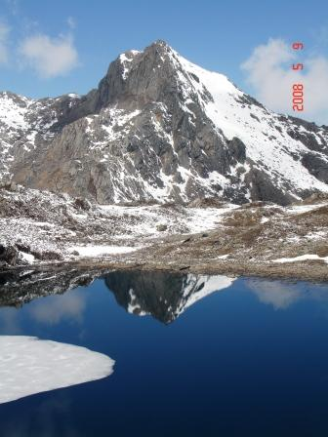
If developed properly, the new Budhanilkantha-Samundratar-Gosaikunda trekking trail would be the shortest trekking trail from Kathmandu to Gosaikunda encompassing through the two National Parks, Shivapuri National Park at the mid-hill and Langtang National Park at High Mountain. Beside this, this trail would connect the popular pilgrimage site the Budhanilkantha (Bishnu) at Kathmandu to the Gosaikunda (Shiva). This trail comprises several beautiful landscape, forest types, and series of lakes (more than 15 lakes) along the trail. The majestic view of Gaurishankar, Dorjelakpa and Manalsu range can also be seen from the southern part of Gosaikunda.

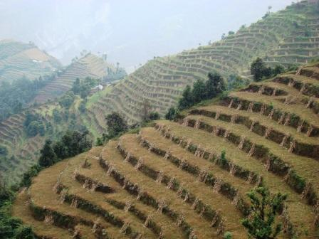
Starting from the Budhanilkantha, the trail passes through the Shivapuri ridge, Likhu river valley, Manebhanjung (Sun set view), Samundratar (local fish), Bhagmara (folded landscape), Malabhanjang, Sagar Lake, and other several lakes along the southern part of Goshaikunda/Suryakunda. After Gosaikunda, the visitors may continue the trek via Dhunche or via Helambu/Chisapani areas. Some eco-lodge should be established from Malabhanjang to Gosaikunda section to run the tea house tourism in this new trail.

The proposed itinerary for the new trekking trail is given below:

Days | From | To | Remarks
1 | Budhanilkantha (1400m.) | Alchhe (1790m.) | 4 hours
2 | Alchhe (1790m.) | Manebanjyang (1780m.) | 5 hours
3 | Manebanjyang (1780mt.) | Baghamara (1825m.) | 6 hours
4 | Baghmara (1825mt.) | Sagarkunda ( 2915m) | 5:30 hours
5 | Sagarkunda ( 2915mt.) | Yeklekunda (3800m) | 7:00 hours
6 | Yeklekunda (3800mt.) | Gosainkunda (4380m) | 7:00 hours

From Gosaikunda visitor can choose the options among the trails via Dhunche, Thadepati or via Rahuchuli/Kalche.
Preliminary feasibility study of Helambu-Panchpokhari trekking trail

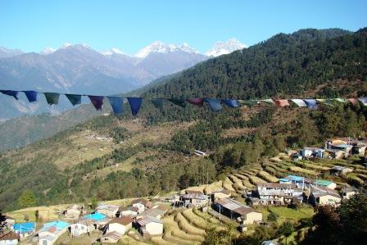
A preliminary feasibility study of Helambu-Panchpokhari-Chautara circuit was carried out by CEST Nepal in January 2008. Located within the eastern part of Langtang National Park (LNP) at the laps of Dorje-Lakpa Himal, this area is highly potential for tourism with its pristine forest and wild animals like Red Panda, Snow Leopard; rich Hyolmo and Tamang culture; beautiful wetland like Panch Pokhari, beautiful landscape of Melamchi and Indrabati river valley and majestic mountain views of Dorje-Lakpa and Gaurishanka Himal.

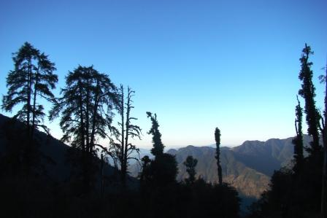
Helambu area is already developed tourism destination and quite popular for Sherpa/Hyolmo culture and lifestyle. Panchpokhari area is a emerging trekking destination which can be packaged with the Helambu. Panchpokhari area also lies at the adventure trekking route to Kyangin/Langshisa via the Till Man pass.

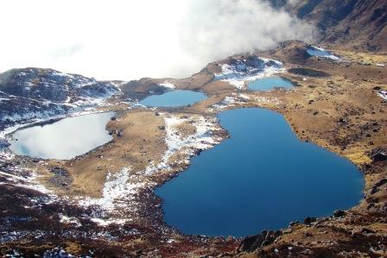
A team of explorer comprising Mr. Ram Chandra Sedai and Nabin Kumar Gupta of CEST Nepal and a local Mr. Kanchha Tamang of Bhotang VDC, Sindhupalchowk visited and explored the circuit. Up to the Bhotang VDC, a tea house trekking can be operated with some improvement on accommodation facilities with proper training and infrastructure development. After Bhotang and up to the Panchpokhari areas, some seasonal eco lodge should be established with the collective effort of Langtang National Park, VDCs, DDC Sindhupalchowk and TAAN.

The proposed itineraries for Helambu-Panchpokhari-Choutara trekking circuit are given below:

- From Melamchi-Timbu site

Days | From | To | Remarks
1 | Kathmandu | Timbu | By jeep/bus
2 | Timbu | Tarkeghang
3 | Tarkeghang | Shermathang
4 | Shermathang | Bolgoan
5 | Bolgoan | Chhimdi
6 | Chhimdi | Noshimpati
7 | Noshimpati | Panchpokhari/Noshimpati
8 | Panchpokhari | Chhimdi
9 | Chhimdi | Dhap
10 | Dhap | Chautara/Saule/Nawalpur
11 | Chautara | Kathmandu | By jeep/bus

- From Chautara/Saule or Nawalpur site

Days | From | To | Remarks
1 | Kathmandu | Chautara | By jeep/bus
2 | Chautara | Dhap
3 | Dhap | Chhimdi
4 | Chhimdi | Noshimpati
5 | Noshimpati | Panchpokhari
6 | Panchpokhari | Chhimdi
7 | Chhimdi | Bolgoan
8 | Bolgoan | Shermathang
9 | Shermathang | Tarkeghang
10 | Tarkeghang | Timbu
11 | Timbu | Kathmandu | By jeep/bus

Preparation of tourism development and management plan of Manakamana, Betini and Bakreshwori areas for Nepal Tourism Board

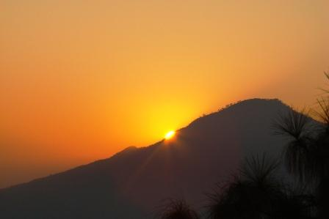
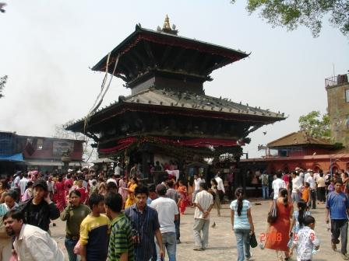
On behalf of Nepal Tourism Board, CEST Nepal prepared and submitted a Tourism Development and Management Plan of Manakamana, Betini and Bakreswori areas of Gorkha district. The popular Manakamana temple is already developed as a major pilgrimage site after the operation of Cable car. Now the plan aims to attract more visitors at Manakamana areas by linking visitors with the culturally rich Betini village and naturally beautiful Bakreshwori hill. Betini village is one of the largest and beautiful Magar villages full of potential for Home-stay activities and cultural programme. Bakreshwori hill located at 1700m high in Mahabharat range is best for the scenic view of Mountain ranges comprising Annapurna range to the west and Langtang and Dorje-Lakpa Himal range to the east. Major mountain ranges closely seen from the hill are Manaslu Himal, Buddhha Himal, Ganesh Himal etc. The site is equally best located for the scenic landscape of Mahabharat range, Daraundi and Marsyangdi river. Besides natural attractions, Bakreshwori hill is also popular for Bakreshwori temple and Siddha Gufa.

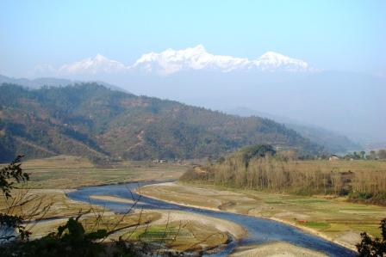
During the plan preparation phase, a series of household visits, field observations, household survey, accommodation facilities survey, village level planning workshop was carried out and a draft plan was shared at the DDC Gorkha with the district level stakeholders including all political parties, Government line agencies, NGOs and private sectors. The final draft was then shared at Nepal Tourism Board. During the sharing workshop at NTB, besides NTB personnel, Mr. Dipendra Purush Dhakal, Dr. Siddhartha Bajracharya and Mr. Major Manandhar (of Manakamana Darsan Pvt. Ltd) provided technical feedback on the draft plan. The plan is supposed to be implemented by the respective communities, Manakamana Area development Committee, respective VDCs and DDC Gorkha with the additional support from Manakamana Darsan Pvt. Ltd and Nepal Tourism Board.

The possible itineraries for Manakamana, betini and bakreshwori areas of Gorkha are given bellow:

Kathamndu-Manakamana-Beteni-Bakreshwori route (2 night 3 days package)
Days | From | To | Activities
1 | Kathmandu | Beteni | Cable car, Manakamana temple, home-stay experience
2 | Betini | Bakreshwori/ Manakamana | Observing the scenic mountain view and beautiful landscape, evening Arati at Manakamana
3 | Manakamana | Kathmandu | Morning arati, cable car, jeep/micro drive to Kt.

Kathamndu-Manakamana-Beteni-Bakreshwori –Gorkha Bazar route (4 night 5 days package)
Days | From | To | Activities
1 | Kathmandu | Manakamana/Beteni | Cable car, Manakamana temple, home-stay experience
2 | Betini | Bakreshwori | Observing the scenic mountain view and beautiful landscape, sunset and sun rise view
3 | Bakreshwori | Gorkha | Sunrise view, morning view of Manaslu range, trekking through the folded terrain of Taklung, drive to Gorkha
4 | Gorkha | Gorkha | Visit historic Gorkha Darbar, Gorkha Musuem, Upper Kot and other places
5 | Gorkha | Kathmandu | Drive through the Daraundi and Trishuli river

Kathamndu-Manakamana-Beteni-Bakreshwori and Pokhara/Chitwan
Days | From | To | Activities
1 | Kathmandu | Beteni/Manakamana | Cable car, Manakamana temple, home-stay experience
2 | Betini | Bakreshwori/ Manakamana | Observing the scenic mountain view and beautiful landscape, evening Arati at Manakamana
3 | Manakamana | Chitwan/Pokhara | Morning arati, cable car, jeep/micro drive to Chitwan or Pokhara

Facilitating Tourism and Hospitality Management Training for tourism entrepreneurs and chamber member at Palpa for Nepal Tourism Board

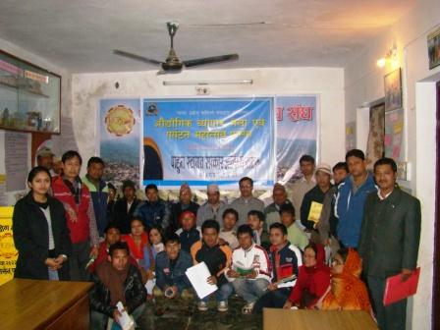
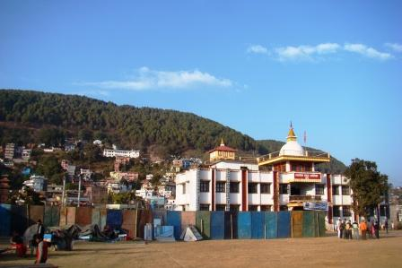
On behalf of Nepal Tourism Board, CEST Nepal facilitated a two days training on Tourism and Hospitality Management Training for the tourism entrepreneurs and planners at Tansen, Palpa. The training programme was jointly organized by the Nepal Tourism Board and Palpa Chamber of Commerce and Industry (PCCI), Palpa in the eve of Trade fair and Tourism festival 2008. Mr. Ram Chandra Sedai, delivered sessions on tourism management and Mr. Paras Sharma delivered sessions on hospitality management.

The participants of the training were briefly oriented on the basic concepts of tourism and tourism management, tourism potentials of Palpa, possible tourism package at Palpa and Tansen and basic principles and practice of hospitality for tourism industry.

Exhibiting and disseminating tourism products by participating the exhibitions

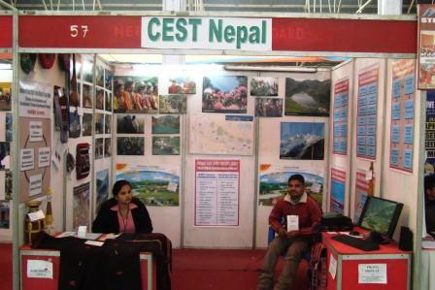
With the view to disseminate the rural tourism products to the potential markets, CEST Nepal has been participating at various tourism related exhibitions and fairs held at Kathmandu. As a part of this mission, CEST Nepal participated at the following two exhibition/fair at Kathmandu

- Participating at the National Exhibition programme jointly organized by FNCCI and Nepal Tourism Board at Bhrikutimandap, Kathmandu from 6 to 10 December 2007. During the exhibition, CEST Nepal exhibited the following
- Flex materials on rural tourism development process to inform and aware planners and academicians about the rural tourism development practices
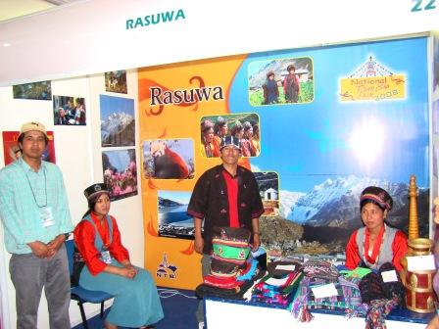
- Demonstrating steel photographs of major tourism attractions
- Displaying digital photographs of major tourism attractions and tourism development processes
- Displaying various crafts items of Rasuwa

- Technical assistance to the District Development Committee, Rasuwa for participating at National exhibition of rural tourism products organized by Nepal Tourism Board at United World Trade Centre, Tripureshwor,from …. 2008.

Assisting Dhorpatan Hunting Reserve to prepare Eco tourism component plan as a part of its Integrated Management Plan

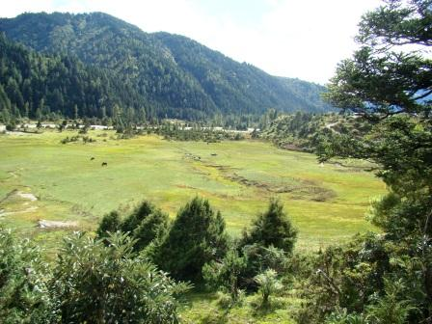
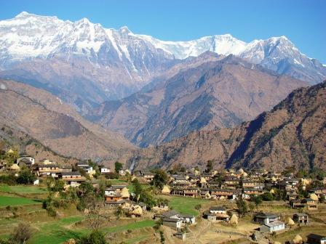
CEST Nepal assisted Dhorpatan Hunting reserve (DHR) to prepare its component plan of Eco Tourism as a part of its Integrated Management Plan. Mr. Nabin Kumar Gupta, Planning and Monitoring Officer of CEST Nepal visited and interacted with the community people at Gurja, Dhorpatan, Maikot areas during may 2008. Mr. Ram Chandra Sedai, Executive Director of CEST Nepal visited Dhorpatan areas, prepared a draft component report and shared with the district level stakeholders at Baglung. The draft plan is being endorsed by the Ministry of Forest and Soil Conservation, after a centre level consultation workshop at the Department of National Parks and Wildlife Conservation.

Besides Eco-Tourism component, DHR Management Plan comprises Core Area management component, Hunting Management component and Buffer Zone management plan. Besides adventure trophy hunting of Blue Ship and Himalayan Thar, DHR is a highly potential ecotourism activity including wilderness walking, sports activities, observing scenic view of Gurja Himal, Manapathi Himal, Dhaulagiri Himal and Annapurna Himal range. DHR is also a habitat of indigenous people like Nauthar, Chhantal, Magar and marginalized people like Bishwokarma.

Dhorpatan Hunting Reserve can be promoted for the following three separate package of tourism:
- 9 days soft trekking at Beni-Jaljala-Dhorpatan-Burtibang circuit
- Trophy hunting of Blue ship and Thar
- 18 to 24 days Long haul trek to Dolpa via Dhorpatan

A brief itinerary of 10 days soft trekking at Beni-Jaljala-Dhorpatan-Burtibang is given below:

Days | From | To | Remarks
1 | Kathmandu | Beni | By jeep/bus
2 | Beni | Darbang
3 | Darbang | Takam/Shibang
4 | Takam/Shibang | Lumsum
5 | Lumsum | Jaljala
6 | Jaljala | Dhorpatan
7 | Dhorpatan | Burtibang
8 | Burtibang | Harichour/Tansen | By jeep/bus
9 | Harichour/Tansen | Baglung/Lumbini | By jeep/bus
10 | Baglung/Lumbini | Kathmandu | By jeep/bus

Community Awareness and Tourism promotion project (CATPP), Changunarayan

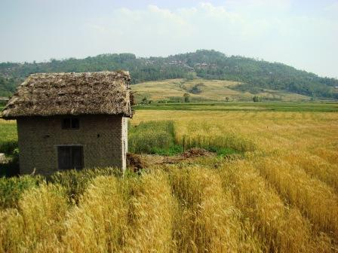
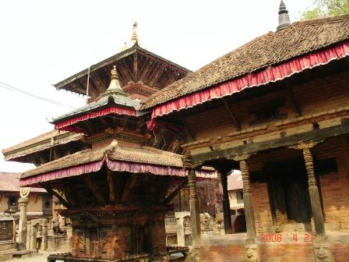
CEST Nepal has been implementing a community based tourism promotion project entitled Community Awareness and Tourism Promotion Project (CATPP) at Changunarayan since February 2008. Changunarayan area is one of the world heritage Site listed sites in Kathmandu. Located at the northern-west part of Bhaktapur city, Changunarayan temple is supposed to be an oldest temple in Nepal established during the King Mandev. The temple is enriched with the presence of ten incarnations of Gods, some master piece of Asia such as Bishowrupa, Garuda and other several artifacts.

Changunarayan area is already known to the tourist market and some day hiking tourist visit Changunarayan area during their travel to Nagarkot and Shankhu area. The present tour package to Changunarayan focuses only the temple and ignores other associated potentials at the area. Due to the lack of sufficient tourism promotional efforts, the area is not getting much tourist at present.

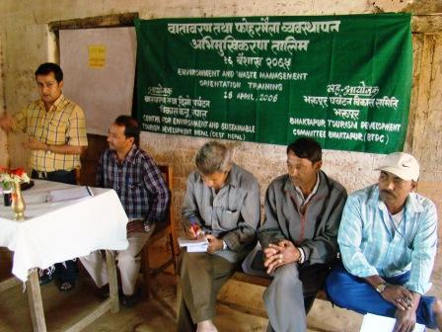
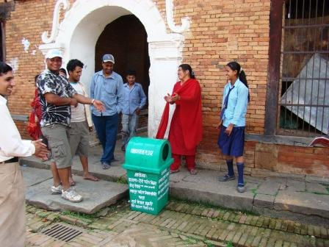
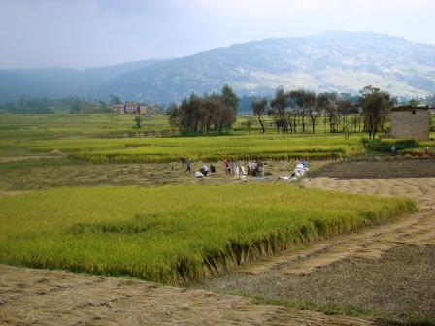
CATPP is a joint effort of CEST Nepal and Bhaktapur Tourism Development Committee (BTDC) with some financial support from Surya Nepal Pvt. Ltd under its Corporate Social Responsibility (CSR) component under the theme of Surya Nepal Prakriti and Khem Paryatan. Currently Changunarayan Tourism development Committee (CTDC) has been coming as a new stakeholders to join hands with CEST Nepal. Beside these, Nepal Tourism Board has been supportive to CATPP primarily in the capacity enhancement and promotional efforts.

The CATPP in Changunarayan aims at strengthening the capacity of local community to diversify the tourism products and package at Changunarayan and attract more tourists with the appropriate tourism promotional efforts.

Till dates, following activities have been undertaken in a bid to achieve the goal of the CATPP:
- Orientation workshop on the Community Awareness and Tourism Promotion Project (CATPP)
- Orientation training on environment management and waste management
- Orientation training on tourism development and management
- Orientation training on sustainable tourism development practices to the newly established Changunarayan Tourism development Committee (CTDC)
- Two waste collection campaigns
- Installation of rubbish bins (10)

Following activities are under preparation as a part of CATPP by CEST Nepal.
- Placement of tourism attractions board at different places reflecting the major tourism attractions, packages and facilities
- Placement of signage and arrow posts
- Development and distribution of promotional brochure
Lumbini Heritage Based Tourism promotion Project/SATIDP

CEST Nepal completed Lumbini Heritage based Tourism Promotion Project in 2017.

